The Detroit Yacht Club has teamed up to infuse the rigorous science, technology, engineering, and math (STEM) curriculum with the outdoor fun through the sport of sailing. First ever of its kind in the country as the DYC’s program provides access, opportunity, and experience for DYC Junior Sailors and University Prep Schools students alike.

Date | Event  (Note: Regattas are intended for qualified racing students)
Mon, June 19-Fri, Aug 11 | 2017 Learn to Sail & Racing Season Program Term
Monday, June 19, 2017 | First Day of DYC Jr. Sailing Program
Monday, June 19, 2017 | Pre-Season Meeting (Coaches Only @ CSYC @ 5:30pm)
Saturday, June 24, 2017 | GYPC USODA Great Lakes Championship
Sunday, June 25, 2017 | GYPC USODA Great Lakes Championship
Tuesday, June 27, 2017 | GPC Opti Clinic + One Day Opti & O'Bic Regatta
Wednesday, June 28, 2017 | GPC Opti Clinic + One Day Opti & O'Bic Regatta
Thursday, June 29, 2017 | NSSC Regatta Bemis w/ Spinn
Friday, June 30, 2017 | Bemis 420 Regatta (DRYA Trophy Event)
Thursday, July 6, 2017 | PYC Regatta - All Fleets
Friday, July 7, 2017 | PYC Regatta - All Fleets
Tuesday, July 11, 2017 | CSYC Two Day Regatta
Wednesday, July 12, 2017 | CSYC Two Day Regatta
Thursday, July 13, 2017 | CSYC Team Racing Invitational
Tuesday, July 18, 2017 | GPYC Clinic + One Day Regatta All Fleets
Wednesday, July 19, 2017 | GPYC Clinic + One Day Regatta All Fleets
Thursday, August 3, 2017 | BYC Two Day Regatta All Fleets
Friday, August 4, 2017 | BYC Two Day Regatta All Fleets
Friday, August 4, 2017 | Last Day for DYC Non-Racing Students
Saturday, August 5, 2017 | DYC FAMILY DAY
Monday, August 7, 2017 | DYC Regatta
Monday, August 7, 2017 | Coaches Debrief Meeting
Tuesday, August 8, 2017 | DYC Around the Island
Thursday, August 10, 2017 | 2017 DRYA Season Awards Banquet @ DYC
Friday, August 11, 2017 | End of DYC Jr/ Sailing
Saturday, September 9, 2017 | GPYC Hosts Junior Olympics
Sunday, September 10, 2017 | GPYC Hosts Junior Olympics

TYPICAL DAY*
- Sailor Meeting Point/Check-In/Attendance  - Instructional/Chalk Board Talk  - Overview of AM/PM Activities (Depending on Weather)  - Safety Gear Check  - Rigging Boats  - Entering Water/Sail | - Supervised Lunch (Underage All Day Students must enroll separately)  - Sailor Meeting Point/Check out/Leave for day  - Specialty days are also incorporated such as Pirate Day, Family Day, Boat Race Day

CURRICULUM
SAILING SKILLS
- Boat handling
- Sailing fundamentals and terminology
- Safety and right-of-way rules
- Racing & Regatta Skills
ACADEMIC CONTENT
- On the water learning
- Science (physics, environment, weather)
- Technology (maps, compass, GPS, underwater exploration)
- Engineering (boat design, wind power)
- Math (geometry, navigation)
- History (American, world)
CONTENT SOURCES
- US Sailing and American Red Cross participant manual, Start Sailing Right, National Sailing Hall of Fame (NSHOF), Learning Math and Science through Sailing, Learning American History through Sailing
- US Sailing
- REACH – STEM topics from a sailing perspective

RESOURCES & INSTRUCTORS
- Coaches
- Educators
- Volunteers
- Invited subject matter experts from Michigan DNR, Dossin Great Lakes Museum, Detroit Historical Society, or others

SAILOR RESPONSIBILITIES
- Recognize that SAFETY is #1 Priority
- Wear Life Jacket AT ALL TIMES on the WATER
- Prerequisite: Pass Swimming Test prior to Program start date
- (50 Meters, Tread Water min of 12 minutes) - No exceptions
- Follow Coach Direction & Follow/Adhere to Code of Conduct
- Understand DYC Ground/Facility Rules
- Pick up / Drop off Points
- Consider Academic Grade/Eligibility Requirements
- Maintain/Bring Sailing Manual Daily

SAILOR OUTFITTING
- Label your belongings
- CLOSED Toed Boat Shoes or Tennis Shoes
- Bathing Suit, Hat, Shirt, Towel
- Warm change of clothes
- Bag or backpack to keep belongings in
- Life jacket with whistle (most important)
- Sunscreen / Chapstick
- Glasses/Sunglasses with croakies or other fastener

For more information regarding the DYC’s Junior Sailing Program, please contact:

Director Sergei Lie cell: 313-319-7325 email: sergeilie@hotmail.com
Ron Gmeiner cell: 313-300-2373 email: rong@spemco.com
Lynn Gmeiner cell: 313-205-0596 email: rlgmeiner@wowway.com

FLEET DESCRIPTIONS
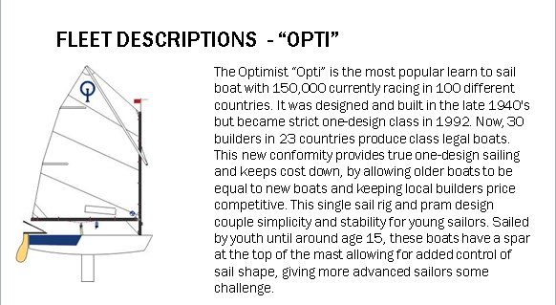
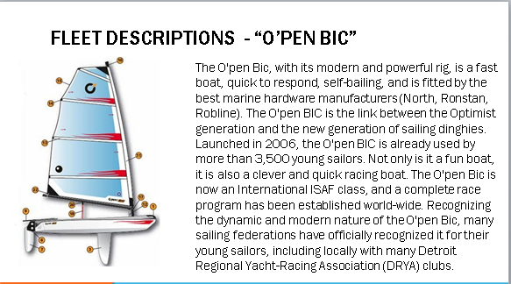

FLEET DESCRIPTIONS (continued)
