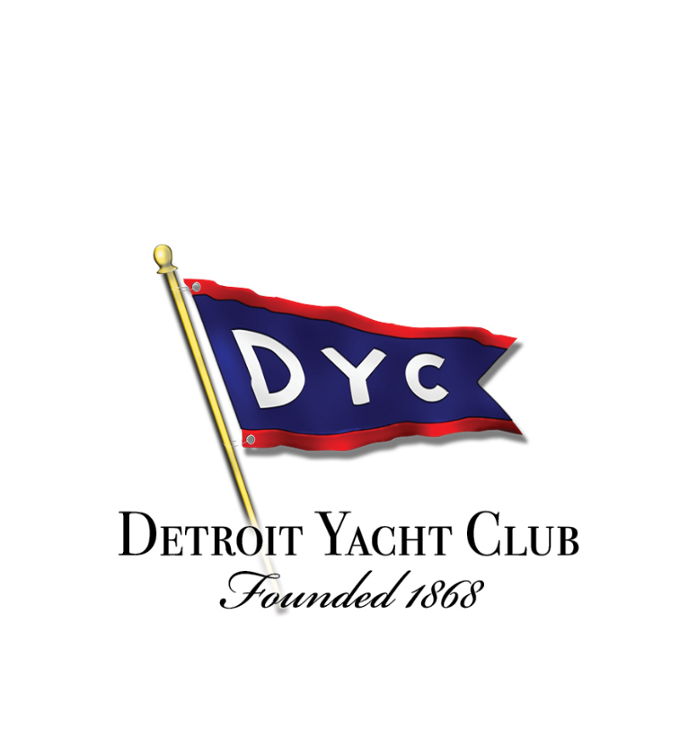
The Detroit Yacht Club
An Exclusive Location with an Inclusive Spirit

Welcome to the DYC established in 1868, North America’s largest clubhouse with almost 100,000 sq. ft of unique grandeur in our historically registered building. The DYC can be your relaxing retreat while creating lifetime bonds of friendship and memories formed through shared interests. Our family of diverse cultures, ages, talents, and interests band together for one of life’s special treasures:
The Luxury of Fun.

Our private island adjacent to the beautiful Belle Isle State Park creates a true Resort in the City. We have more amenities and year-round activities than any other private club in the Great Lakes region. We were proudly voted “The Best Place in Metro Detroit” to keep your boat by Hour Detroit. One of the greatest strengths of the DYC is our non-boating members, who outnumber boaters and help keep the club buzzing all-year round. We can host almost any occasion from your high powered business lunches to family movies nights and almost every sporting activity, party, and gala you can imagine. Share your imagination and our staff will work to make it reality.

If you want delectable American food, we have you covered. Our Club includes formal dining rooms, private dining options, casual waterside dining, and a poolside cafe. We even deliver food and refreshments to your boat. Do you have a special event to celebrate? We have many beautiful rooms for you including the largest grand ballroom in Michigan. If you want to dance, we have weekly entertainment and the friendliest yacht lounge on the planet! Want quiet time? We have dozen of indoor and outdoor hideaways for you to relax.
Commodore Ray Batt
This is only a small portion of what we offer. The DYC is more a
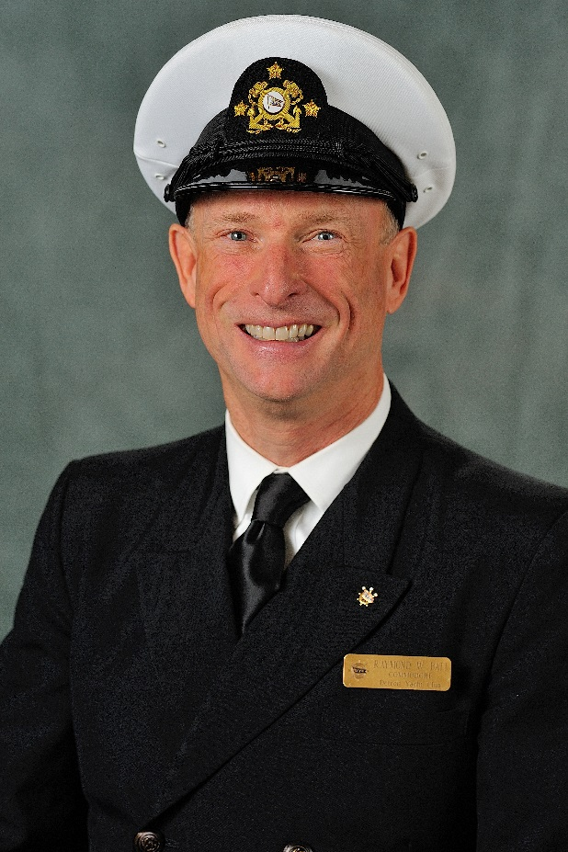
“We” than a “What” and we look forward to sharing with you
what makes the DYC so special. Join us in creating lifelong memories.

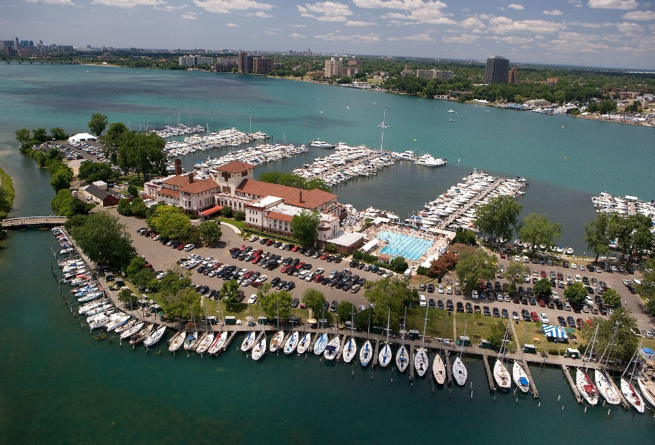
This is where you belong!

